EXP:2 230701217-NITHIN KUMAR K

MEMORY RECALL TASK

**EX No 2:**

**Design a UI where users recall visual elements (e.g., icons or text chunks). Evaluate the effect of chunking on user memory.**

# A Memory Recall Task Game in UI design is a game or interactive activity that tests a user's ability to remember and recall visual or textual elements.

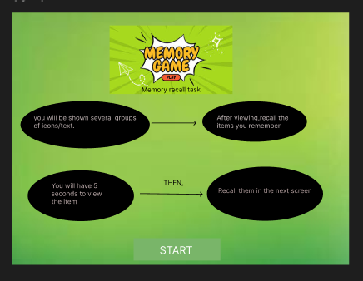

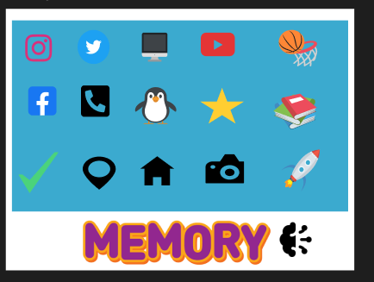

The game presents users with information—such as images,Icons—for a limited time(5 seconds). After the information disappears, users must recall and reproduce it correctly. This tests and improves their short-term memory and cognitive skills.

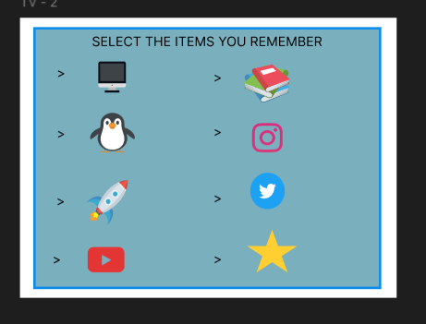

NOW, YOU HAVE TO SELECT THE ITEMS GIVEN ABOVE WHICH YOU HAVE REMEMBERED FROM THAT LARGE IMAGE

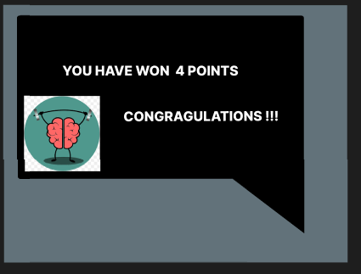

**UI Design Considerations**

* **Minimalist Layout:** Reduce distractions so users can focus on the memory task.

**WE HAVE A VERY SIMPLE INTERFACE FOR THE USERS TO REMEMBER THE ICONS OR IMAGES.**